Task 01 – What database models do you know?

Database models:

* Hierarchical (tree)
* Network / graph
* Relational (table)
* Object-oriented

Task 02 – Which are the main functions performed by a Relational Database Management System (RDBMS)?

RDBMS systems typically implement:

* Creating / altering / deleting tables and relationships between them (database schema)
* Adding, changing, deleting, searching and retrieving of data stored in the tables
* Support for the SQL language
* Transaction management (optional)

Task 03 – Define what is "table" in database terms.

Database tables consist of data, arranged in rows and columns:

* All rows have the same structure
* Columns have name and type (number, string, date, image, or other)

Task 04 – Explain the difference between a primary and a foreign key.

While primary key enforces uniqueness on the column(s) of one table, foreign keys define a relationship between two tables.

Task 05 – Explain the different kinds of relationships between tables in relational databases.

There are three types of relationships:

One-to-one: Both tables can have only one record on either side of the relationship. Each primary key value relates to only one (or no) record in the related table.

One-to-many: The primary key table contains only one record that relates to none, one, or many records in the related table.

Many-to-many: Each record in both tables can relate to any number of records (or no records) in the other table.

Task 06 – When is a certain database schema normalized? What are the advantages of normalized databases?

Normalization of the relational schema removes repeating data

Non-normalized schemas can contain many data repetitions

* 1st Normal Form
  + Data is stored in tables
  + Fields in the rows are atomic (inseparable) values
  + There are no repetitions within a single row
  + A primary key is defined for each table
* 2nd Normal Form
  + Retains all requirements of 1-st Normal Form
  + There are no columns that do not depend on part of the primary key (if it consists of several columns)
* 3rd Normal Form
  + Retains all requirements of 2-nd Normal Form
  + The only dependencies between columns are of type "a column depends on the PK"
* 4th Normal Form
  + Retains all requirements of 3-rd Normal Form
  + There is one column at most in each table that can have many possible values for a single key (multi-valued attribute)

Task 07 – What are database integrity constraints and when are they used?

* Integrity constraints ensure data integrity in the database tables
  + Enforce data rules which cannot be violated
* Primary key constraint
  + Ensures that the primary key of a table has unique value for each table row
* Unique key constraint
  + Ensures that all values in a certain column (or a group of columns) are unique
  + Foreign key constraint
    - Ensures that the value in given column is a key from another table
  + Check constraint
    - Ensures that values in a certain column meet some predefined condition

Task 08 – Point out the pros and cons of using indexes in a database.

Advantages: use an index for quick access to a database table specific information. The index is a structure of the database table the value of one or more columns to sort

Disadvantages: too index will affect the speed of update and insert, because it requires the same update each index file.

Task 09 – What's the main purpose of the SQL language?

The main purpose of the SQL language is allowing users to access data on an ad hoc basis required giving them a language in which to express their requests.

Task 10 – What are transactions used for? Give an example.

Transactions are a sequence of database operations which are executed as a single unit:

Either all of them execute successfully

Or none of them is executed at all

Example:

A bank transfer from one account into another (withdrawal + deposit)

If either the withdrawal or the deposit fails the entire operation should be cancelled

Task 11 – What is a NoSQL database?

* NoSQL (non-relational) databases
* Use document-based model (non-relational)
* Schema-free document storage
  + - Still support CRUD operations  
      (create, read, update, delete)
    - Still support indexing and querying
    - Still supports concurrency and transactions
* Highly optimized for append / retrieve
* Great performance and scalability
* NoSQL == “No SQL” or “Not Only SQL”

Task 12 – Explain the classical non-relational data models.

The non-relational data model would look more like a sheet of paper. In fact, the concept of one entity and all the data that pertains to that one entity is known in Mongo as a “document”, so truly this is a decent way to think about it.

Task 13 – Give few examples of NoSQL databases and their pros and cons.

* NoSQL databases
  + Data stored as documents
  + Single entity (document) is a single record
  + 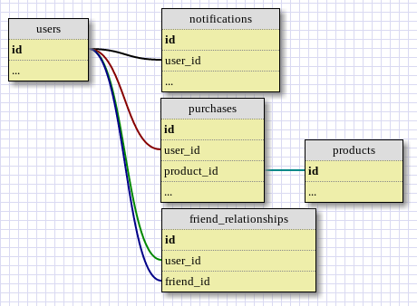Documents do not have a fixed structure